**LAB EXERCISE – SHEET1**

1. Create 5 Users – using useradd cmd

a. Kevin

b. Marie

c. adrian

d. Laura

e. einstein

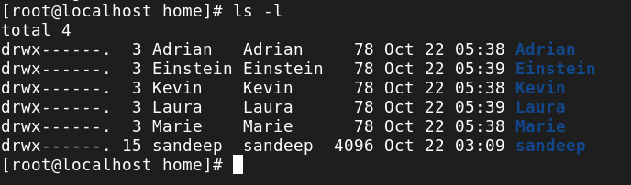

3. Set password for einstein , Kevin and Laura

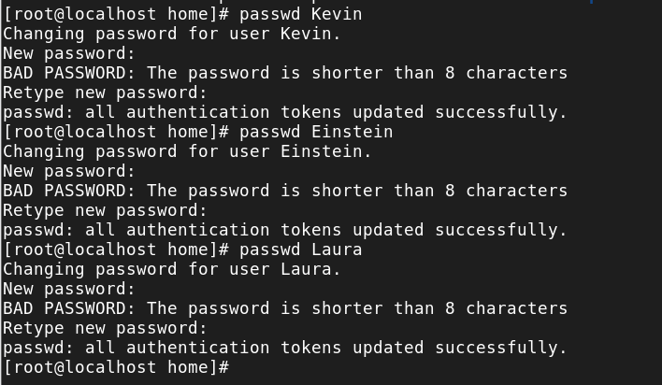

4. Change Kevin Password

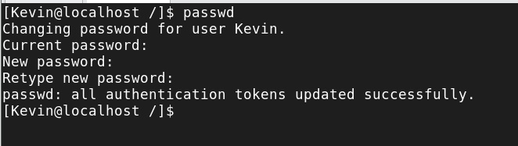

5. Create 5 empty files under your home directory (under your username) using **touch** cmd →

a. maths b. science c.History d. english e.Social

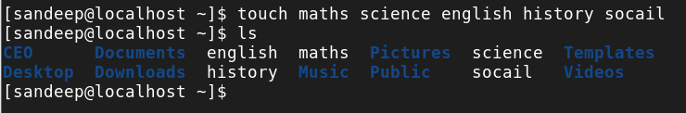

6. Go to “ / “ directory from your **home directory** and list down all the files using

a) ls b) ls-la c) ls –ltr

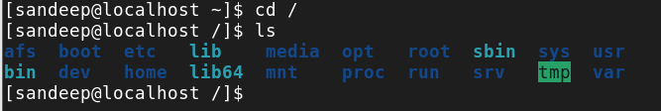

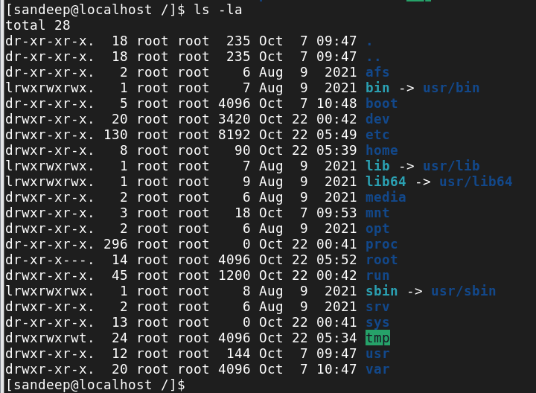

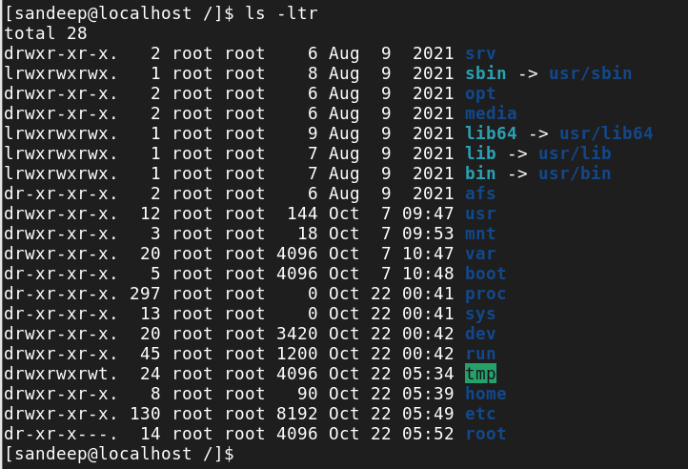

7. Go to “etc” directory from your **home directory** and list down all the files using a.

a) ls b) ls-la c) ls –ltr

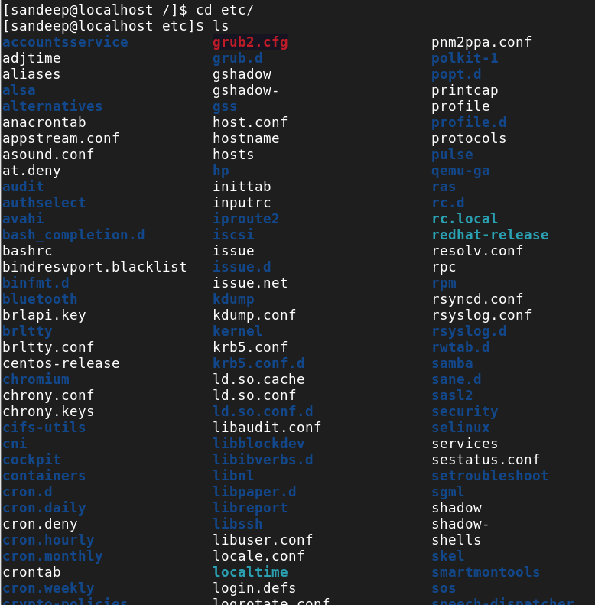

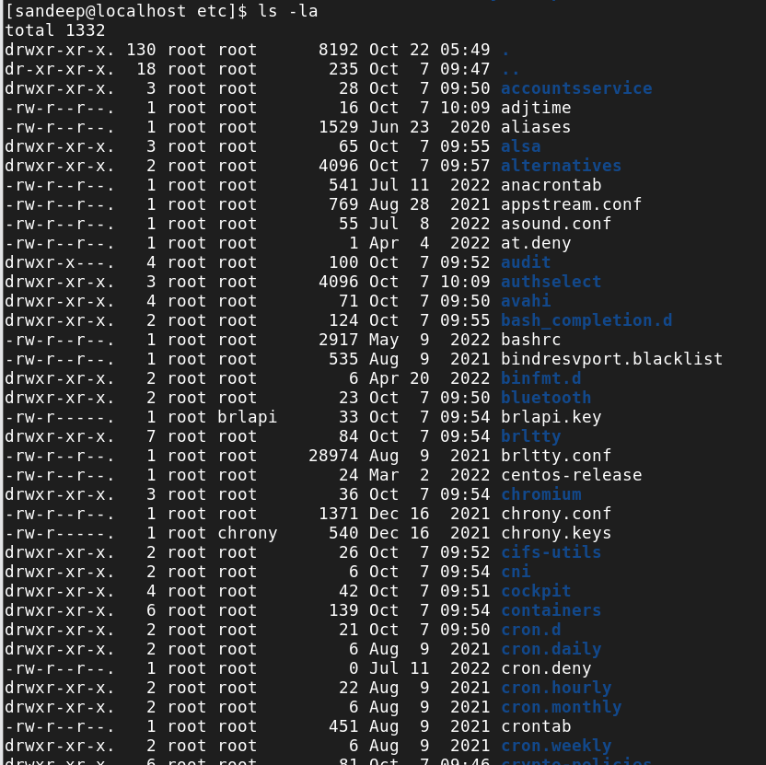

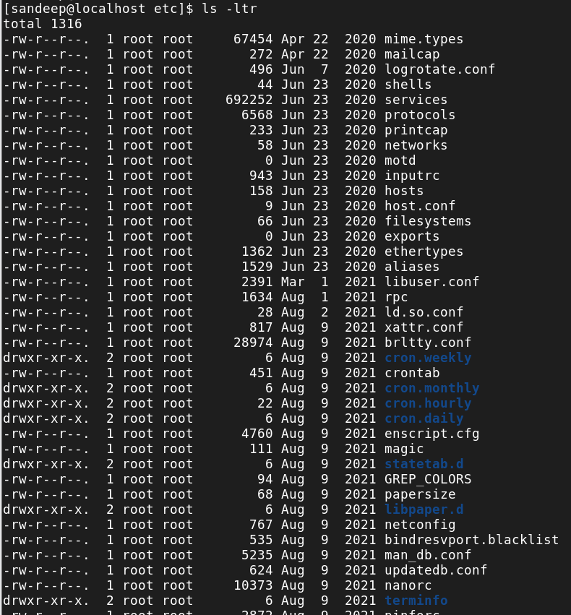

9. Go to “var/spool” directory from your **home directory** and list down all the files using

a) ls b) ls-la c) ls –ltr

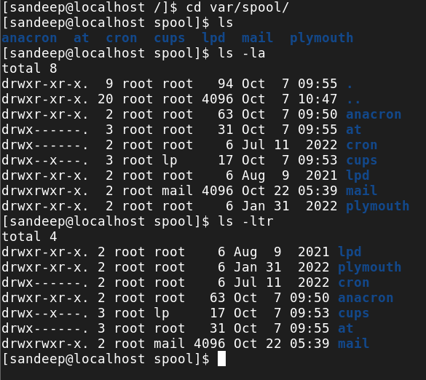

10. Go to “tmp” directory from your **home directory** and list down all the files using

a) ls b) ls-la c) ls –ltr

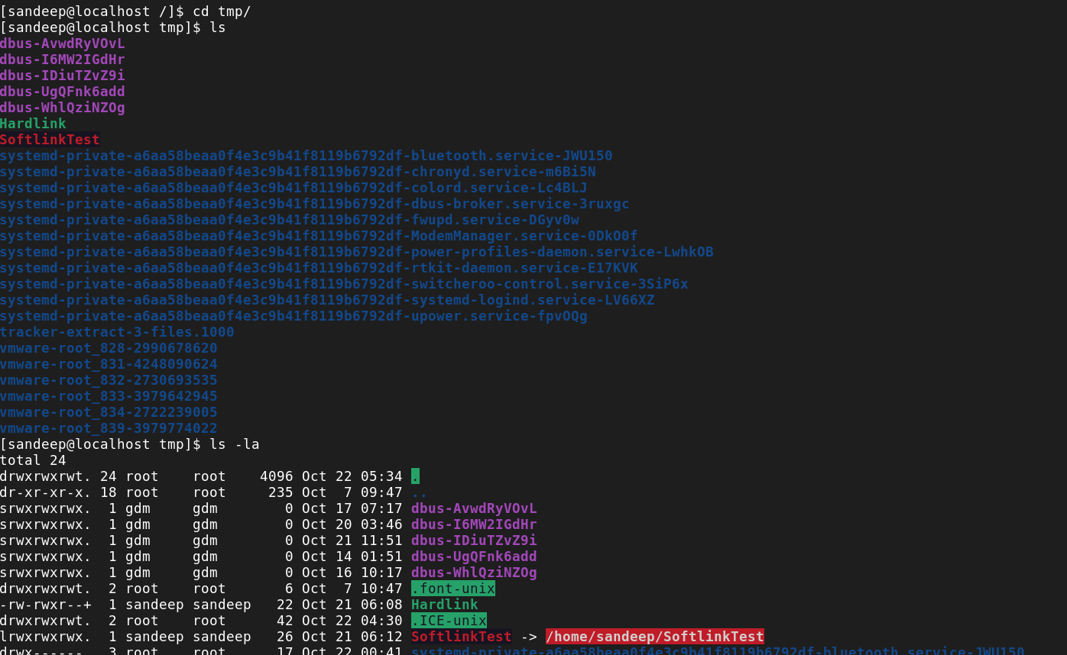

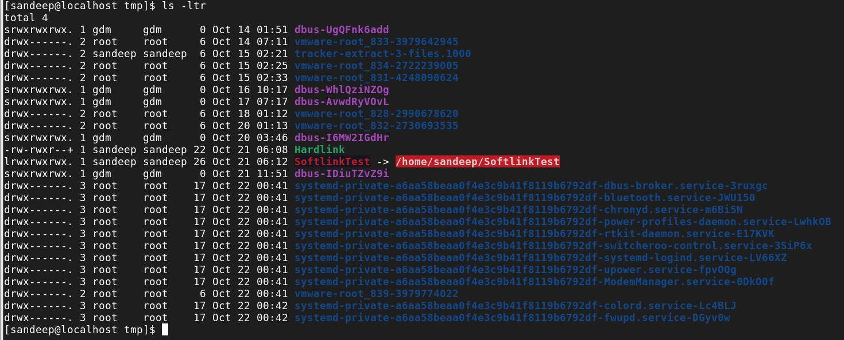

12. Use pwd, **hostname** and **whoami** cmd under your home directory.

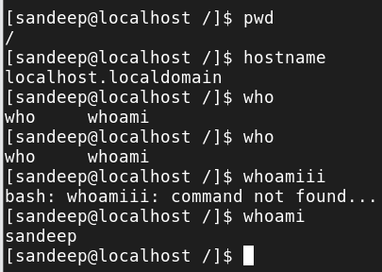

13. Change user using **su – username** cmd

a. From root  go to einstein  laura Kevin Adrian yourhome

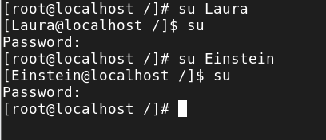

14. Use **exit** cmd and observe the changes.

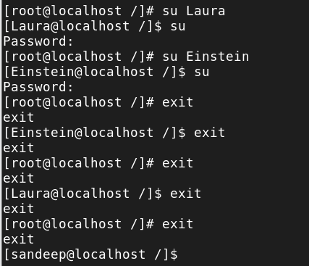

16. Create directories under your home directory (your username),use **cd** cmd to navigate thru them



